**STAT 40001/STAT 59800 Statistical Computing Fall 2020**

**Lab-7**

1. The National Highway System Designation Act was signed into law in 1995. It abolished the federal mandate of 55 mph speed limits. The data ***speed (****provided in the Brightspace****)*** shows percentage changes in interstate highway traffic fatalities from 1995 to 1996 are provided in the Blackboard.

Important note: Please note that it is a tab-delimited file.

1. Print first 5 lines of the data



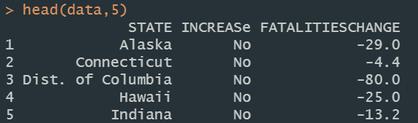

1. Draw the histogram of the percentage changes in interstate highway traffic fatalities from 1995 to 1996

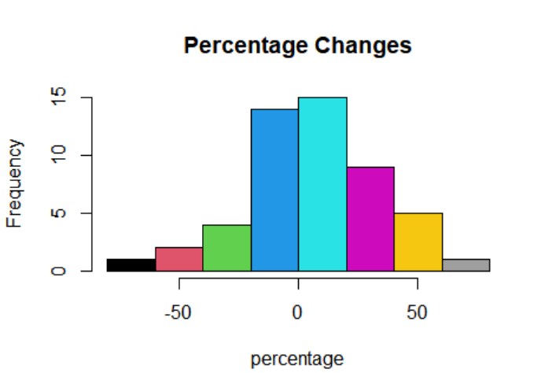

1. Compare the speed limit and traffic fatalities by displaying a side by side boxplots

The box plot should look as below





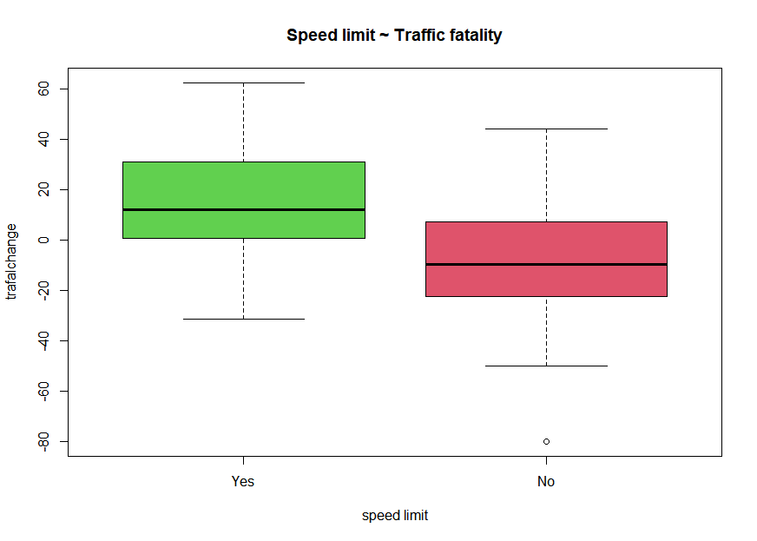



1. The link below includes the crime rates for 50 states in 2005.

<http://datasets.flowingdata.com/crimeRatesByState2005.tsv>

1. Import the dataset in R and name it *crime*.

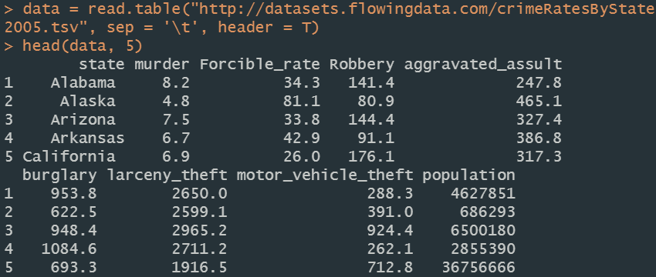

1. How many variables are included in the data



1. Use code below to draw bubble plots

symbols(crime$murder, crime$burglary, circles=crime$population)



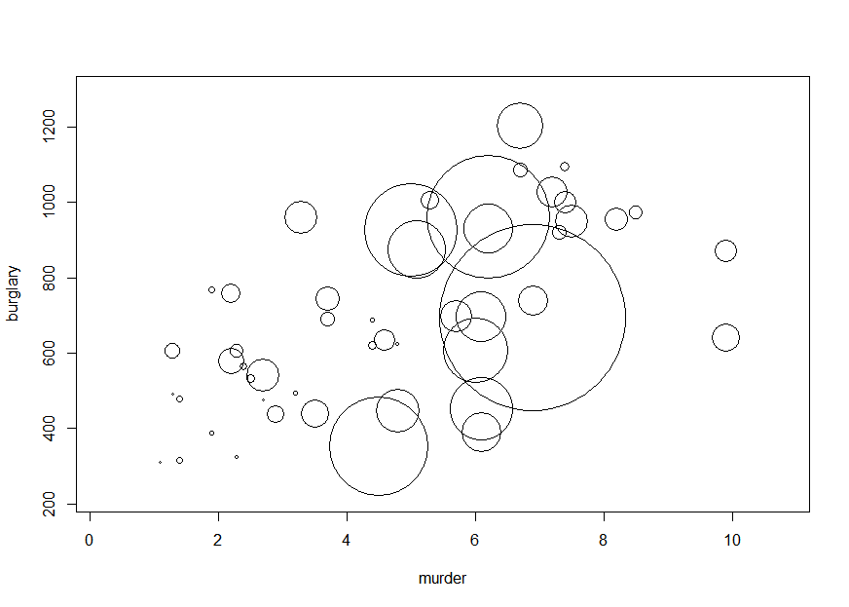

1. Add the name of the states using code:

text(crime$murder, crime$burglary, crime$state, cex=0.5)

You may add option: bg=”red” etc.



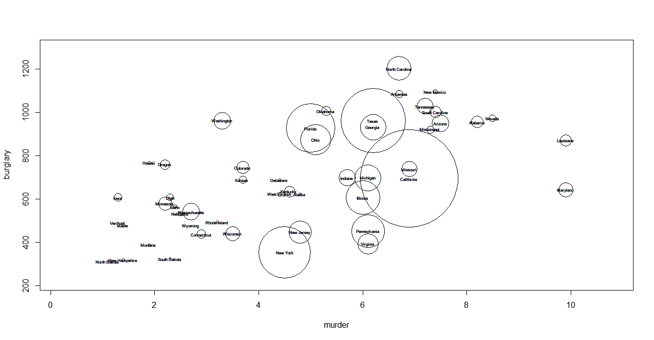

1. The dataset concerning hepatitis are provided in the link below

<https://archive.ics.uci.edu/ml/machine-learning-databases/hepatitis/hepatitis.data>

1. Import the data in R

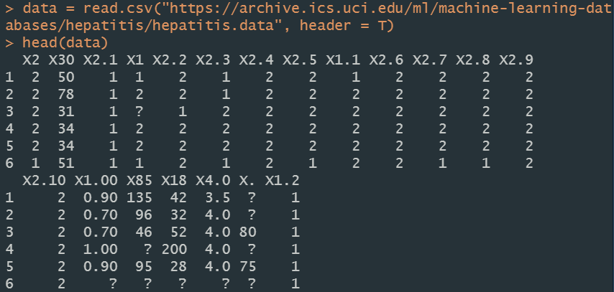

1. Missing values are marked as “? “ Replace them with NA and delete them.





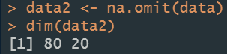

1. How many observations contain missing information?

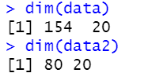

There should be 74 observations that contain missing information.

1. Eleven golfers in a golf tournament play 18 holes each day. The scores for each of the golfers on the four days are given below. Display this data using parallel boxplots. Make sure you have labels the box plots in the order of the days

Friday Saturday Sunday Monday

70 77 81 70

71 78 83 81

75 81 84 81

79 82 84 88

80 83 86 88

81 83 86 89

83 85 87 90

83 85 87 90

84 85 87 91

85 88 88 93

90 89 89 94

